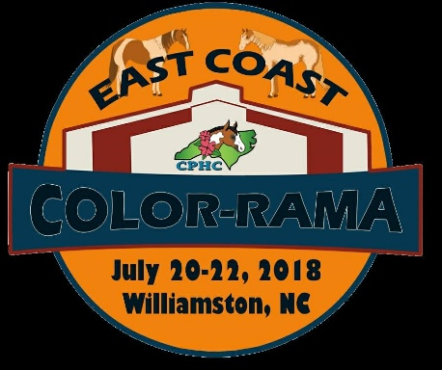
East Coast Color-Rama Pre-Paid Stall Form

Name___________________________________________ Phone # _____________________________
Address _____________________________________________________________________________
Email address ________________________________________________________________________

Number of stalls needed _________________ X $90 = ________________
***YOU MAY PREPAY VIA CHECK OR PAYPAL***
Trainer to be stalled with _______________________________________
Date of Arrival _______________________________ Date of Departure ________________________
Other stall preference requests (i.e. Barn, with friends, etc). We will do our best to accommodate requests but cannot make guarantees.

*PAY BEFORE JULY 5, 2018, AND GET 3 FREE BAGS OF SHAVINGS PER PRE PAID STALL!*

Please email this form to Dana Raynor at mrdraynor1@gmail.com

Mail your check for pre-paid stalls to:
Lori Smith; 1797 Wright Rd; Lexington NC 27292
Pre-Pay through Paypal at cphconline@gmail.com

*** PAYMENTS FOR PRE-PAID STALLS ARE NON-REFUNDABLE ***

